INTEGRATIVE COURSE IN PSYCHOLOGY (ICOPSYCH)

ANALYSIS ON THE RESULT OF PRE-TEST EXAMINATION IN INDUSTRIAL PSYCHOLOGY
APRIL 26, 2025

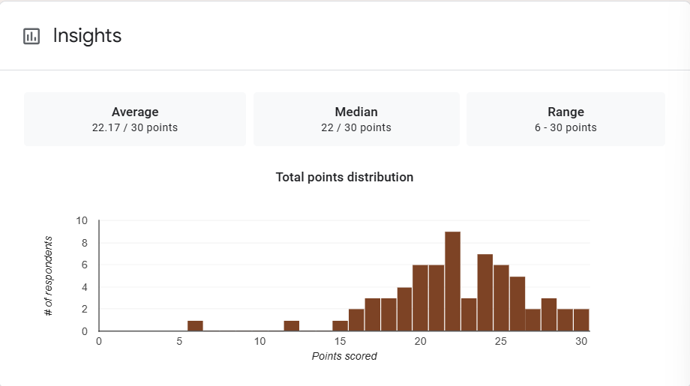

1. Mean Score: 22.17/ 30 points. This indicates the average performance of the group. A mean score of approximately 74% suggests that overall, students performed reasonably well on the exam.

2. Median Score: 22 / 30 points. The median is very close to the mean, which suggests a fairly symmetrical distribution of scores without significant skewness. Half of the students scored below 22, and half scored above.

3. Range: 6–30 points. This is a wide range (24-point spread), showing considerable variability in student performance. While some students achieved full marks, others struggled significantly.

Interpretation Summary:

-The exam results indicate an overall solid performance, with a balanced distribution of scores centred around 22/30.

-However, the wide score range suggests the presence of both high achievers and students who may need additional support.

-The lack of skew in the distribution implies that the exam was generally fair in its level of difficulty.

RATIONALIZATION:

DIFFICULT QUESTIONS:

